LUC@BJTU Weihai Campus

Fundamentals of Communication Systems (CNSCC160) Tutorial 1

Group Number:

Name:

- Identify the key features of analogue and digital signals.

- What is the relationship between period and frequency? What are their units? Give three numerical examples with your explanation.

- What is the Morse code for Lancaster? Try to write Morse code for your name.

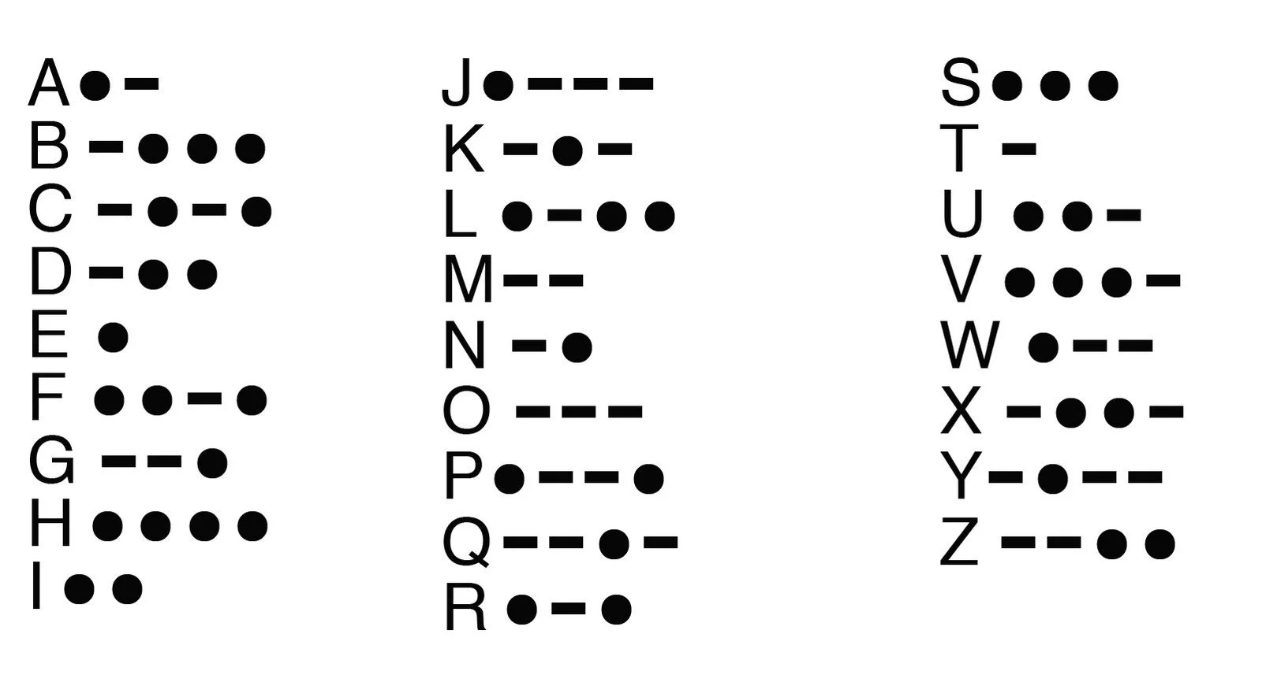

- Explain Period and Frequency .What if a signal maintains a constant amplitude for the entire active time? In such a case, what is the frequency?

- What if a signal changes instantaneously? What if it jumps from one level to another in no time? What is the frequency?

- A digital signal has a bit rate of 10bps, what is the duration of each bit (the bit interval)? Clue: 1000 ms = 1 second

